Preparing the Word of God - checklist

- Prayer to the Holy Spirit

- Read the text at least twice, as if it was completely new to you

- Find any word that would need an explanation (for you and/or the children)

- Research the context of the text: what type of text? When? Where? Historical and cultural context.

- Find what comes before and what comes after in the Scripture

- If possible, read the footnotes and a commentary on the passage

- Research the cross references given, pointing the Old Testament and to the New Testament

- Find any reference to this passage in the Catechism of the Catholic Church (In the Citation Index and the Subject Index)

- Find ONE thing about GOD and ONE thing about US to be passed on to the children from the text.

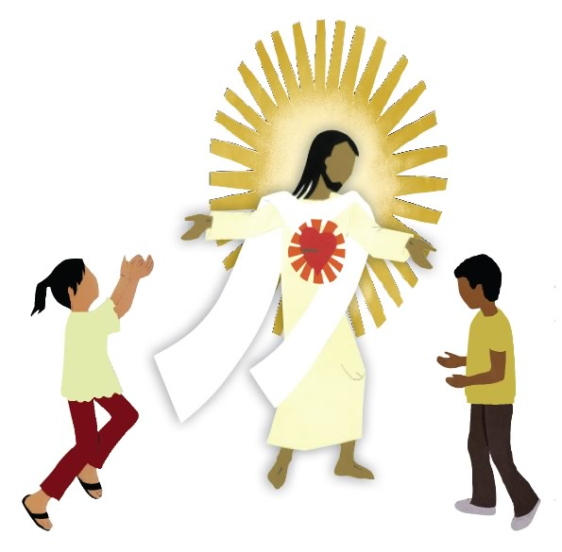
- Prepare the delivery of the session: Where do we stop? What questions do we ask? How do we direct the whole session towards the two things (God and us) and so to an interior discovery of God?

